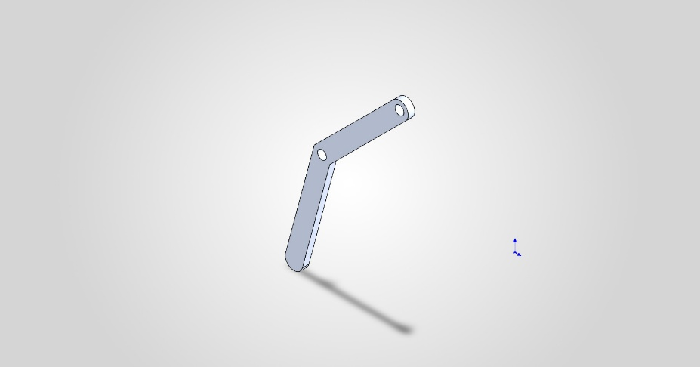
  Simulation of Leg_Triangle
  Date: 04 October 2026
  Designer: Solidworks
  Study name: SimulationXpress Study
  Analysis type: Static
  Table of Contents
  Description 1
  Assumptions 2
  Model Information 2
  Material Properties 3
  Loads and Fixtures 3
  Mesh information 4
  Study Results 6
  Conclusion 8

Description
Static structural analysis of one 6061-T6 aluminium hexapod leg subjected to a 30N downward load. This case represents a higher loading condition to evaluate the leg's structural margin beyond nominal static loading.

Assumptions

Model Information

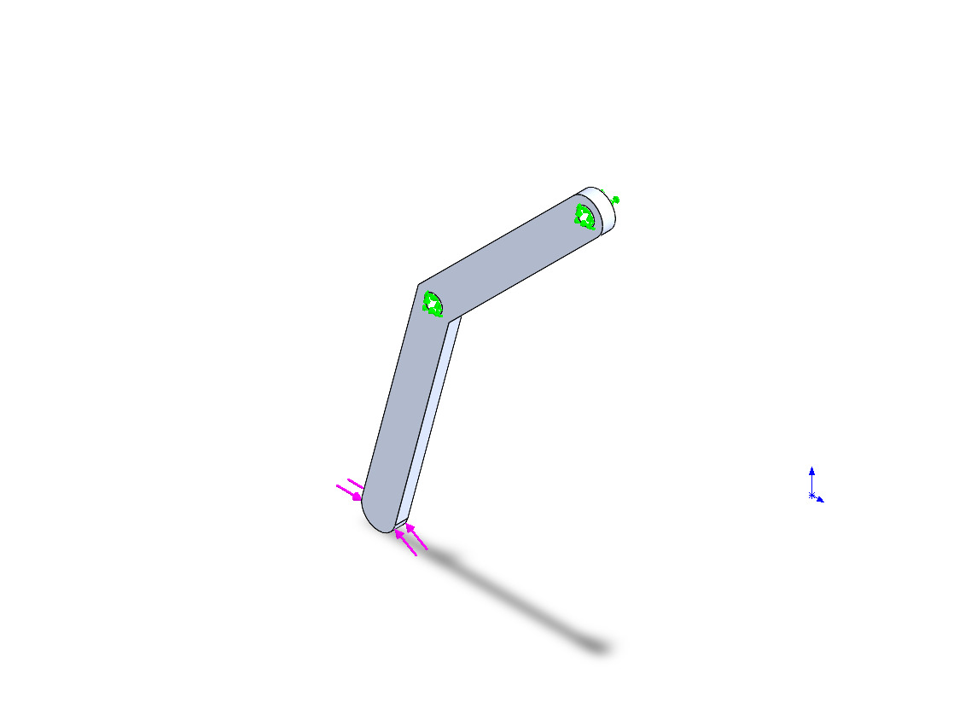
Model name: Leg_Triangle
Current Configuration: Default
Solid Bodies
Document Name and Reference | Treated As | Volumetric Properties | Document Path/Date Modified
Boss-Extrude1  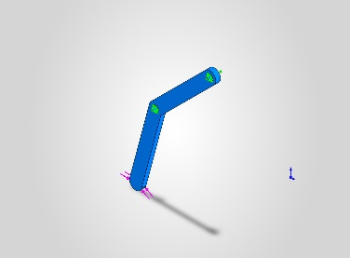 | Solid Body | Mass:0.00670318 kg  Volume:2.48266e-06 m^3  Density:2,700 kg/m^3  Weight:0.0656912 N | C:\Users\E.Kay\ANTARES PROJECT\HEXAPOD\Leg_Triangle.SLDPRT  Oct 3 17:27:41 2026

Material Properties
Model Reference | Properties | Components
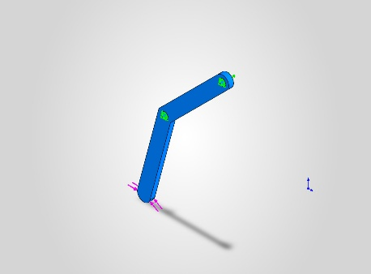 |  | SolidBody 1(Boss-Extrude1)(Leg_Triangle)
  Name: | 6061-T6 (SS)
  Model type: | Linear Elastic Isotropic
  Default failure criterion: | Max von Mises Stress
  Yield strength: | 2.75e+08 N/m^2
  Tensile strength: | 3.1e+08 N/m^2

Loads and Fixtures
Fixture name | Fixture Image | Fixture Details
Fixed-2 | 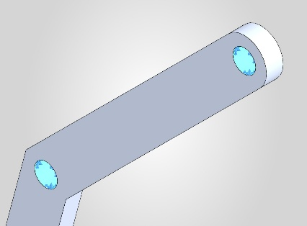
  Entities: | 2 face(s)
  Type: | Fixed Geometry

Load name | Load Image | Load Details
Force-2 (:Per item: 30 N:) | 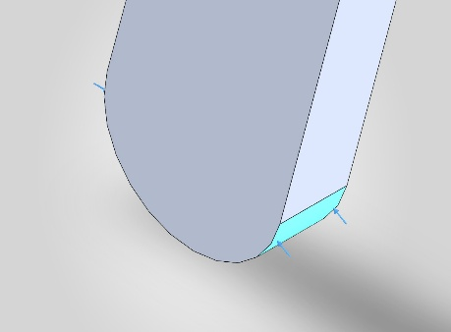
  Entities: | 1 face(s)
  Type: | Apply normal force
  Value: | 30 N

Mesh information
Mesh type | Solid Mesh
Mesher Used: | Standard mesh
Automatic Transition: | Off
Include Mesh Auto Loops: | Off
Jacobian points for High quality mesh | 16 Points
Element Size | 1.35465 mm
Tolerance | 0.0677323 mm
Mesh Quality | High

Mesh information - Details
Total Nodes | 13114
Total Elements | 7741
Maximum Aspect Ratio | 4.157
% of elements with Aspect Ratio < 3 | 99.8
Percentage of elements with Aspect Ratio > 10 | 0
Percentage of distorted elements | 0
Time to complete mesh(hh;mm;ss): | 00:00:10
Computer name:
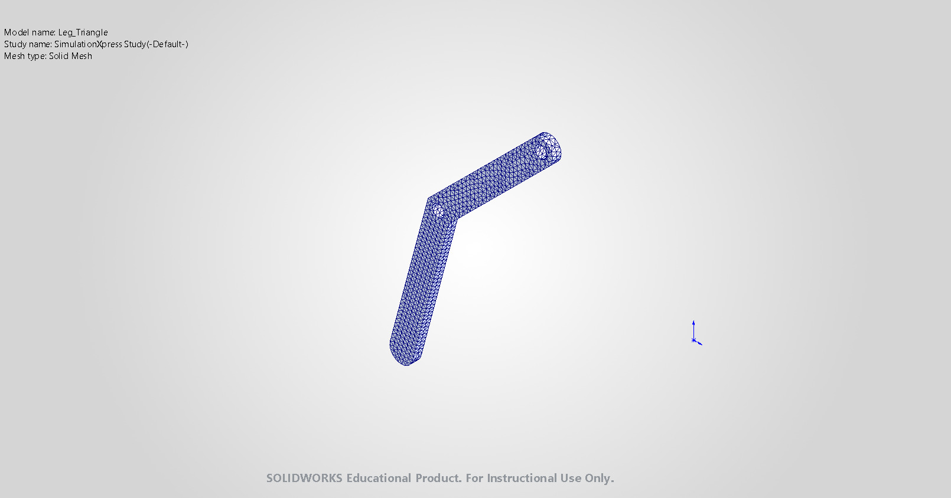

Study Results

Name | Type | Min | Max
Stress | VON: von Mises Stress | 2.988e+01N/m^2  Node: 8499 | 1.194e+06N/m^2  Node: 41
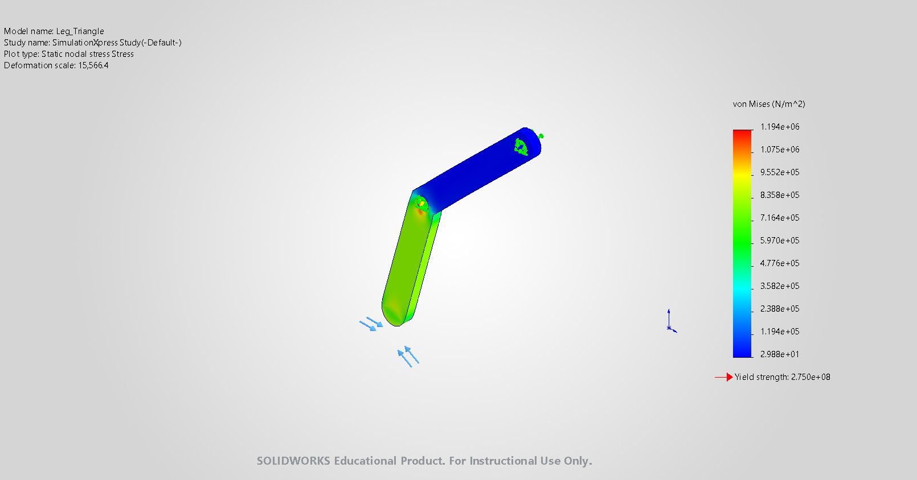
Leg_Triangle-SimulationXpress Study-Stress-Stress

Name | Type | Min | Max
Displacement | URES: Resultant Displacement | 0.000e+00mm  Node: 1 | 6.065e-04mm  Node: 89
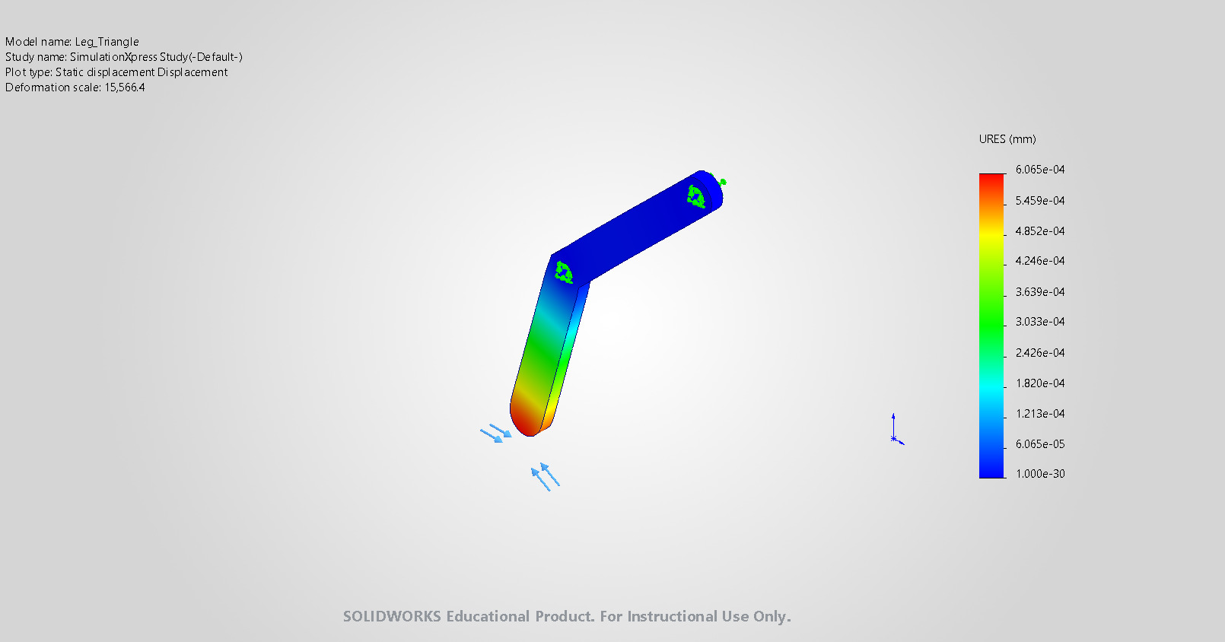
Leg_Triangle-SimulationXpress Study-Displacement-Displacement

Name | Type
Deformation | Deformed shape
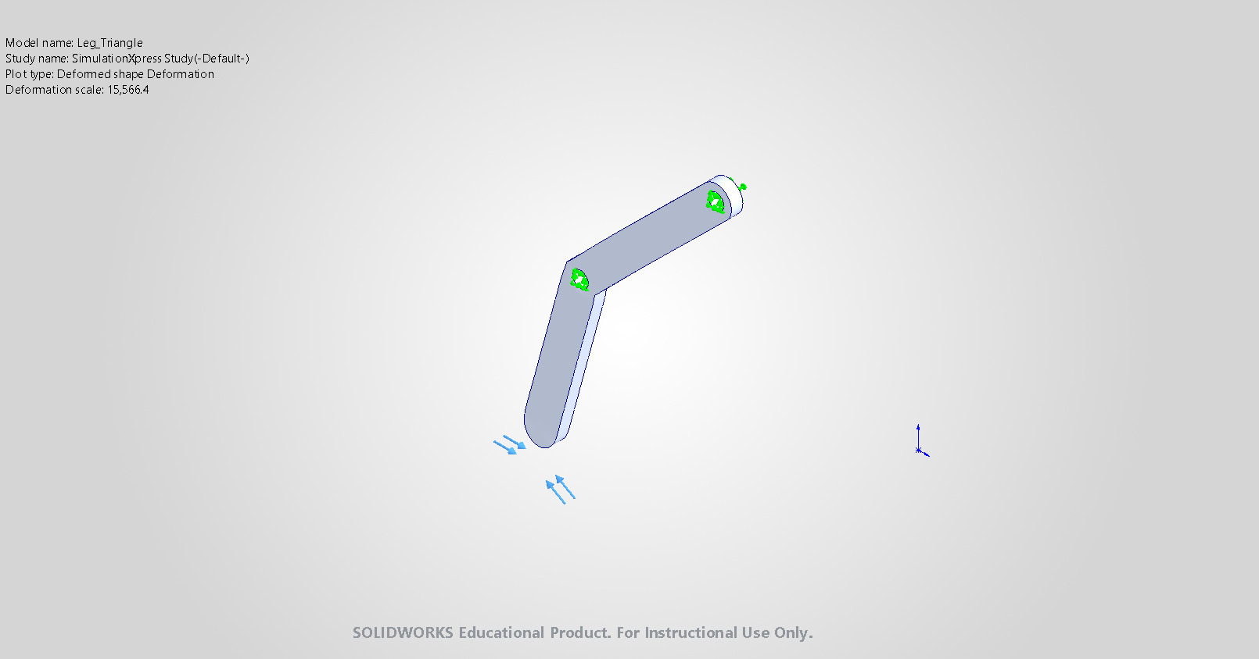
Leg_Triangle-SimulationXpress Study-Displacement-Deformation

Name | Type | Min | Max
Factor of Safety | Max von Mises Stress | 2.303e+02  Node: 41 | 9.204e+06  Node: 8499
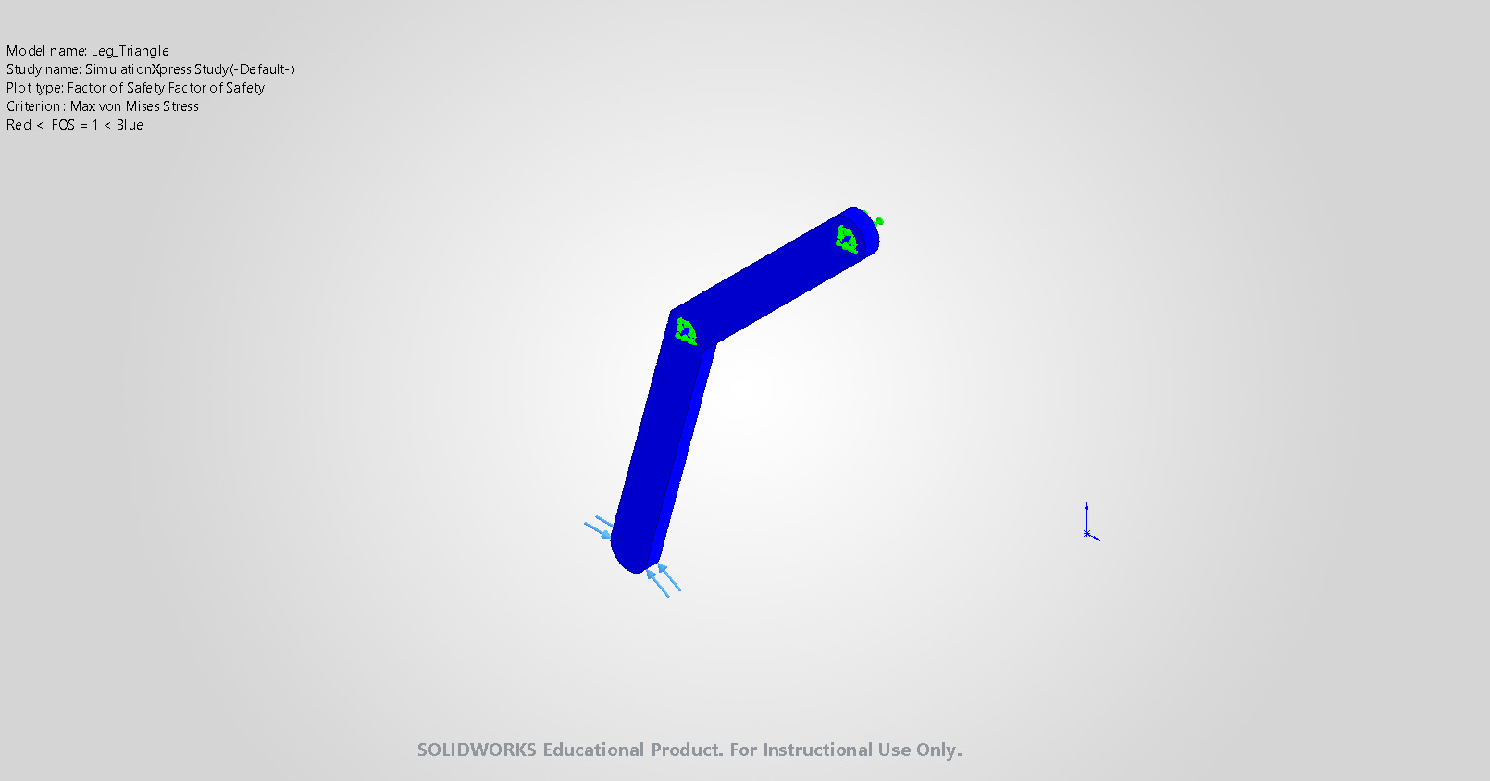
Leg_Triangle-SimulationXpress Study-Factor of Safety-Factor of Safety

Conclusion
Under applied 30N load, the leg remains within the defined material strength limit. Maximum displacement was 6.065e-4mm and minimum factor of safety was 230.327. The results indicate that the leg maintains structural integrity under the increased static load.

